Southside F.O.O.L.S. Meeting Minutes
April 14, 2016
Called to Order - 1910 hrs.
LODD Roll Call
New Members (1st meeting)
- Joe Keenan
- Mark Folsom
- Mike Sullivan
Minutes
Reviewed. Motion to accept- Stack 2nd Tsokolas. Motion approved.
Treasure’s Report
President DiNicola gave report reviewed. Ending Balance: -$11,219.63. Motion to accept- Orrico 2nd Pesha. Motion approved.
President’s Report – DiNicola
- Updated members on FOOLS Convention July 27-31, 2016
  - Concerns about preparation were discussed.
  - Extend of our involvement/support
    - Training Support
    - Memorial Stair climb
    - Airport transport
  - Matt Benson has offered to be our liaison and he is in need of our help preparing for the stair climb and designing a t-shirt. If you can give Matt some time, please email him at Faceman78@gmail.com.

- April 6 FOOLS School – Firefighter Behavioral Health
  - Big Success! Approximately 40 people attended
  - Thanks to Matt Berk, Chief Grady, Frankfort FPD, 1-800-Board-Up and Andres Medical

- President DiNicola made an appeal to make the Rosecrance Florian Program a designated charity for the SSFOOLS in place of Fire Up a Cure.
  - Dan DeGryse, director of Rosecrance, expressed his appreciation of our support as asked for support for an upcoming seminar on firefighter behavioral health in September.
  - Motion made by Stack to sponsor the seminar in an amount equal to our contribution to Fire Up a Cure in 2015. 2nd by Grady. Discussion about being mindful of spending for charitable organizations. Motion approved unanimously.
- Gave update of May 1st 2016 Chief Shabbona Pow-Wow (4200 Pine Bluff Rd, Morris, IL)
  - If interested in helping instruct please contact Mike Moulesong at fyerock17@msn.com.

Vice President’s Report-Scott
Ronald McDonald House – Brother Kraft unable to attend.
Upcoming Dates:
- May 10 -LUNCH
- August 23 -LUNCH
Please Contact Jeff at jeffkraft@msn.com or (773) 520-4347.

I.T.- No report.
Hope Hospital- Brother Johnson unable to attend next Hope Hospital Visit on May 26th. Brian Scott will take the lead for the day. Passed out a sign-up sheet for the 5/26/16 10am visit. Please make every effort to attend. If interested, Brian can be contacted at: brianrscott@comcast.net or 708-220-1933

Upcoming visits:
September 28, 2016 10AM
We need ten people each day.

1st trustee- No report.
2nd trustee- No report.
Sergeant Of Arms- No report.
Old Business- Podium has been delivered to the Fire Museum of Greater Chicago 5218 South Western Avenue. Thanks to Pat McManus, Jorge and Noah Buckley for all their hard work on this project!
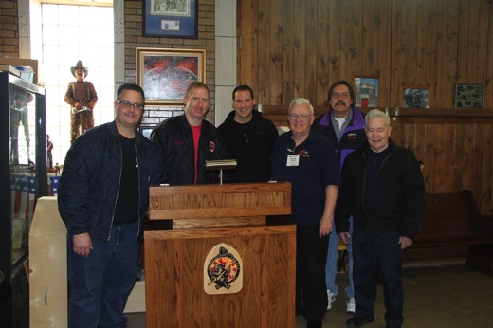
New Business- None
Good of the Order – No items.
HTH: $91
Training: Behavioral Health Issues and Experiences - Excellent group discussion about specific traumatic experiences as well as overall job stress and its impact upon us both physically and psychologically.
Motion to Adjourn –Meeting ended at approximately 2030hrs

Respectfully Submitted,
VP Brian R. Scott

