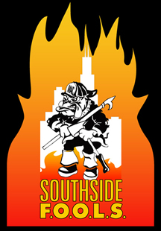
Southside F.O.O.L.S. January 2015 Monthly Minutes
1900 hrs meeting called to order
Ritual of the Can
LODD roll call
Leadership Committee: Presentation on Duty
New Members: Mike Fox Retired North Maine FDP. Sponsor Dave Traiforos. 3rd Meeting Jamie Angel Chicago Ridge Sponsor Chris Bednarek. All in favor motion Passed
Guests: Dr Canner Fire Up A Cure
Meeting Minutes form October: Motion Wilson, 2nd Lenzen motion passed
Treasurer’s Report: Rich Stack motion 2nd Moulesoung motion passed
President’s Report: Thanks to all members for the support. Congrats to the Fool of the Year Chirs Bednarek. Survey was sent out and the e board meet to discuss the survey results and discuss the needs of the organization. Anybody who fell of the wagon and wants to pay the dues, executive board is allowing a pass on late fee’s up until March 31st. If late fee was paid, your dues are covered for 2016.
Vice President’s Report: Brian talked about the direction of the organization yet focus why we are all here.
Sergeant Of the Arms: Clothing working on the website for updating
New Business: FOOLS School on April 25th 2015 in Frankfort. VES, Flashover Over, Advanced SCBA, RIT. Chief Shabbona Fire School April 12th. If you are interested in helping out please email Rich Stack.
Mike Iorio training on elevators.
HTH$233
Motion Wilson, Bednarek 2125 adjournment

