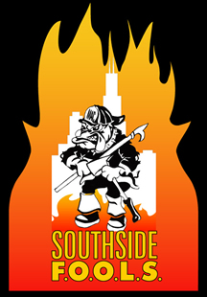
Southside F.O.O.L.S. August 2015 Meeting Minutes
Call to Order 1900 hrs.
Ritual of The Can
Leadership Presentation- Angelo the points of the Maltese Cross (Perseverance)
June meeting minutes read motion Joe Johnson, 2nd Moulesoung
Treasurer’s report read motion made by mckee, 2nd blair. Passed
Presidents Report: Dues are due… Fire Up a Cure-Chief Dory, letter was read from Jason Canner thanking all who helped.
VP report: Hope Hospital visit September 23 sign up passed around. Cook day October 20th please sign up.
IT: Updating as much as I can. Updating Pay Pal to accept 2015 dues. Will be live by Saturday.
Election: Sept 15th votes need to be turned in for the by laws. Nominations are due in September for President, Secretary, and Sergeant of Arms.
1st Trustee: Contact Ed Dagdick to give him history updates on the organization.
SGT of Arms: Nothing
Old Business: Discussion on Podium and a motion. Motion by Joe Johnson 2nd by Mckee. Motion passed.
New Business: Chief Dory talked about Rosecrans and the help they provide for firefighters and their support.
Golf Outing Pat Kenney’s son September 26th Twin Lakes golf course. Motion VP Scott to sponsor a foursome for $280. 2nd McCastland.
President’s meeting in September with the international President. FOOL of The Year start thinking about nominations.
HTH $149
Motion to Adjourn1927 Joe Johnson, Mckee

