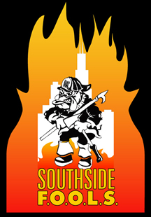
Southside F.O.O.L.S. November 2015 Meeting Minutes
Called 1900 hrs
LODD Roll Call
Leadership Committee- None
New Members: None
Guest: Kim White from IFSI administrator
October Meeting Minutes motion Wilson, 2nd Stack passed
Treasuers Report motion Orrico, 2nd Grady passed
Presidents Report: Fire Museum membership $100 Motion Wilson, 2nd Stack –passed
Childrens Hospital letter was read and they are looking for a donation . Motion by Orrico to spend $1000 for a donation, 2nd Dory-passed
Dues list was presented and a discussion was held, please pay them
Final Thoughts for the group was given
Vice President:
Election Results: Noah Buckley-Secretary, Angelo-SGT Arms, President- DiNicola
RMH- Meeting with them in three weeks to discuss schedule 2016 (3 lunchs and 1 Dinner)
IT- Nothing
Fire Up A Cure- Nothing
Hope Hospital-Oct visit was light but went well, getting dates for 2016
1st trustee-none
2nd Trustee- podium is moving along
SGT of Arms: New T-shirts are in, LODD cards are in and the FOTY award is completed. New coins are being made. Mottion to purchase 100 coins Barna, 2nd Bednarek
New Business: Wreaths Across America motion by Stack to purchase 10 wreaths for $150. 2nd Orrico
Brian Scott – DC of the Evanston FD
Rich Stack- LT Chicago FD (Dec 9th promotional night Navy Pier1900hrs)
Congrats to the FOOL OF THE YEAR- Rich Stack
Motion to adjourn-Wilson, 2nd Orrico

